**المملكة العربية السعودية  
وزارة التعليم  
جامعة الباحة  
كلية علوم الحاسب وتقنية المعلومات  
ITقسم**

**Kingdom of Saudi Arabia  
Ministry of Education  
Albaha University  
Faculty of Computer Science and Information Technology  
Department of InformationTechnology**



Final year project report ( 1 )

A Report submitted in part fulfilment of the degree of BSc.  
In IT..

*Entitled:*

Supply chain management system of electronic virtual products

*Undertaken by:*

439000048

441008559

441014117

441011854

441016824

Musab bin Omair Al-Ghamdi

*Abdulallah Muhammed ALomsari*

Abdullah Hamlan Hindi Al-Ghamdi

Muhammad Abdul Qadir Abdul Rahman Al-Zahrani

Wael Hassan Rizkallah Al-Ghamdi

*Supervised by:*

Academic year: 2022-2023

**Acknowledgements**

Thank God the Lord of the two worlds, Who agreed and helped us to finish this research and come out with this integrated image, and based on the principle that those who do not thank people do not thank God, we extend

our sincere thanks to

**DR.**

who got us on track to do this research and had visible imprints through

his guidance and constructive academic criticism, and we would like to

express our appreciation for your outstanding service to us and the

contributions you made to us in the past. We wish you every success in

your future endeavors

**Table of Contents**

**ACKNOWLEDGEMENTS........................... .................................................................................................3**

**DEDICATION ................................................................................................................................................5**

**ABSTRACT .................................................................... ................................................................................5**

**INTRODUCTION .................................................................... .....................................................................6**

**TABLE OF CONTENTS ....................................................................................................... .......................7**

**CHAPTER I INTRODUCTION.................................................................... ............. .................................8**

**CHAPTER 2 LITERATURE REVIEW.....................................................................................................11**

**CHAPTER 3 FEASIBILITY STUDY...........................................................................................................**

**CHAPTER 4 SYSTEM ANALYSIS............................................................................................................16**

**CHAPTER 4 SYSTEM DESIGN...................................................................... ............................................6**

Chapter 1

INTRODUCTION

**Introduction**

**1.1. Background and Motivation**

**1.2. Problem and Research Questions**

**What is the problem to be solved?**

**Who cares about this problem?**

**What have others done?**

**What is our solution to the problem?**

**1.3. Aim and Objectives**

* Availability 24hr.
* Meet customer needs
* Extend Internationally.
* Increase Trust.
* Create New Trading Partnerships
* Providing product support or customers services.
* Providing corporate information.

.**1.4. Proposed Solution to Problem**  
Building a platform to allow sellers to present thier products to the customer.

These products will be mainly digital cards such as playstation plus, iTunes, and more.

The website will be running 24/7.

The customer will be able to buy any of these products from online.

We are trying to communication easier between the customer and the seller, also we will have a customer support from out side to both the customer and the seller when needed

**Chapter 2**  
**LITERATURE REVIEW**

# SIMILAR WORKS

# Similar works to our project

# Like Card <https://like4card.com/>

# -Rasseed <https://www.rasseed.com/>

# -La3eb https://la3eb.com/ar-sa

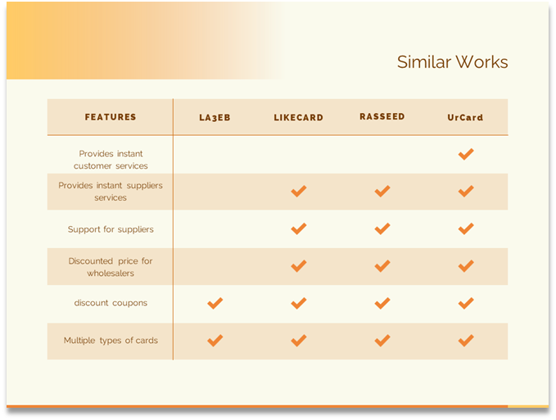

**Chapter 3**  
**FEASIBILITY STUDY**

**3.1.Introduction**  
In a feasibility study, a proposed plan or project is evaluated for its practicality. As part of a feasibility study, a feasibility analysis is used to determine the viability of an idea, such as ensuring a project is legally and technically feasible as well as economically justifiable.

**2.3. Technical Feasibility:**  
The project deals with online buying of card

I use in front end html,css ,Bootstrap whoch make our website response so it work will to mobile or ipad or computer ,javascript spatially jQury .

In backend I choose Laravel which is .

Through this, we reduce the achieve our goal which make this .

**3.3. Operational Feasibility:**  
This project will make it easier for buying a cards and he know it’s details very well.

**4. Scheduling Feasibility:**  
All parts of our project will be completed on time below:  
--2023  
we will meet our requirements easily.

**Chapter 4**

**WEBSITE ANALYSIS**

**Introduction**

Who are the stakeholders? They are the people and entities that get benefit from this site.

what are the user requirements? Use the features, function, and content described in your scenarios to develop your requirements. Your user scenarios should outline the tasks your users want to complete on your site.

And What Does System Requirements Mean? System requirements are the configuration that

a system must have in order for a hardware or software application to run smoothly and efficiently. Failure to meet these requirements can result in installation problems or performance problems.

What about non-functional requirements ? The definition of a non-functional requirement is that it fundamentally determines how a system should behave and that it restricts the behavior of systems

# The stack holders

### Providers who will sale products in the platform

* + To have its products available to everyone and throughout the day
  + Present them the required support and training to use the platform and establish their stores.
  + Achieving an excellent profit rate compared to the traditional method
  + Present them your plan of Marketing and selling policies and payments methods, and their benefits of using your platform and how will cost them.

### Customers who will use the platform to buy cards

* + Easy website to use and understand.
  + Providing all digital cards at competitive prices
  + Present them all information for Return policies, Warranties
  + Present them with the information they need to accomplish the task at hand.
  + Providing all means of assistance such as technical support and communicating with supplier directly and F.A.Q service.

### Support Team

* + Present the required support for the sellers and customers and answering their all questions.
  + Help providers and customers required information to complete their tasks.
  + Present the required technical support for the sellers and customers at real-time to keep platform running on.
  + Monitor all transactions in the platforms to prevent the any risk.
  + Accepting new provider’s orders and confirming they are real providers.

System requirements  
First: the website should allow users to process and apply for a computer after he login   
Second: The website must allow users to log in via

e-mail.  
Third: The website must allow users to inquire at any time.  
Fourth: The website must allow employee to receive notifications and alerts when the customer apply for a computer

* **The Details of Requirement Specification**

### Software

* + - **Functional Requirements**: This section provides requirement overview of the system. Various functional modules that can be implemented by the system.
    - **Registration:** If customer wants to buy the product then he/she must be registered, unregistered user can’t go to the shopping cart.
    - **Login:** Customer logins to the system by entering valid user id and password for the shopping.
    - **Changes to Cart:** Changes to cart means the customer after login or registration can make order or cancel order of the product from the shopping cart.
    - **Payment:** In this system we are dealing the mode of payment by Paypal. We will extend this to credit card, STC etc. in the future.
    - **Logout:** After ordering or surfing for the product customer has to logout.

### Non-Functional Requirements:

* + - Secure access to consumer’s confidential data.
    - 24X7 availability.
    - Better component design to get better performance at peak time.
    - Flexible service-based architecture will be highly desirable for future extension.
    - On-Functional Requirements define system properties and constraints.

# Requirements

### Software

* + Enable many payment methods.
  + Fast website for quick access.
  + Registration If customer wants to buy the product then he/she must be registered.
  + Report Generation After ordering for the card.
  + Security, Reliability, Maintainability.
  + SSL for the secure access.

### Hardware

* + Hosting server for website and database.
  + Computers 4GB Ram and 500GB Hard Disk for Support Teams, and Marketing team.

### User Requirements:

* + - maintain an acceptable speed at maximum number of uploads allowed from a particular customer as any number of users can access to the system at any time. Also, the connections to the servers will be based on the attributes of the user like his location and server will be working 24X7 times.

### Technical Issues:

This system will work on client-server architecture. It will require an internet server, and which will be able to run PHP application. The system should support some commonly used browser such as IE, Mozilla Firefox, chrome etc.

**Interface Requirement:** Various interfaces for the product could be.

**Login Page, Registration Form**, there will be a screen displaying information about product that the shop having, If the customers select the buy button, then another screen of shopping cart will be opened. After ordering for the product, the system will send one copy of the bill to the

customer’s Email address

### ▪ Hardware

•      **Hardware Interface**: Hardware requirements for insurance on internet will be same for both parties which are as follows:

•      **Processor**: Dual Core RAM:2 GB **Hard Disk**:320 GB **NIC**: For each party

•      **Communication Interfaces**: The two parties should be connected by LAN or WAN for the communication purpose.

# Benefits of the project

* Providing product support or customers services
* Grow Sales rates.
* Expand Overseas.
* Increase Trust.
* Create New Trading Partnerships.

# Benefits for the buyer

* Customer will get good prices Because of the competitive environment we have
* Our platformer will meet The customer’s needs by Providing all kinds of Digital cards
* Direct dealing with suppliers

# Benefits for the seller

* Provide enough space to display suppliers' products
* Lower cost to the supplier than traditional sales methods
* 24-hour supplier support services
* Customers reach the offered products in a better way to achieve the best possible benefit

Chapter 4

**WEBSITE DESIGN**

# System Design Specification

### Data Flow Diagram (DFD):

* + Level 0

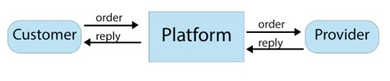

* + **Level 1**

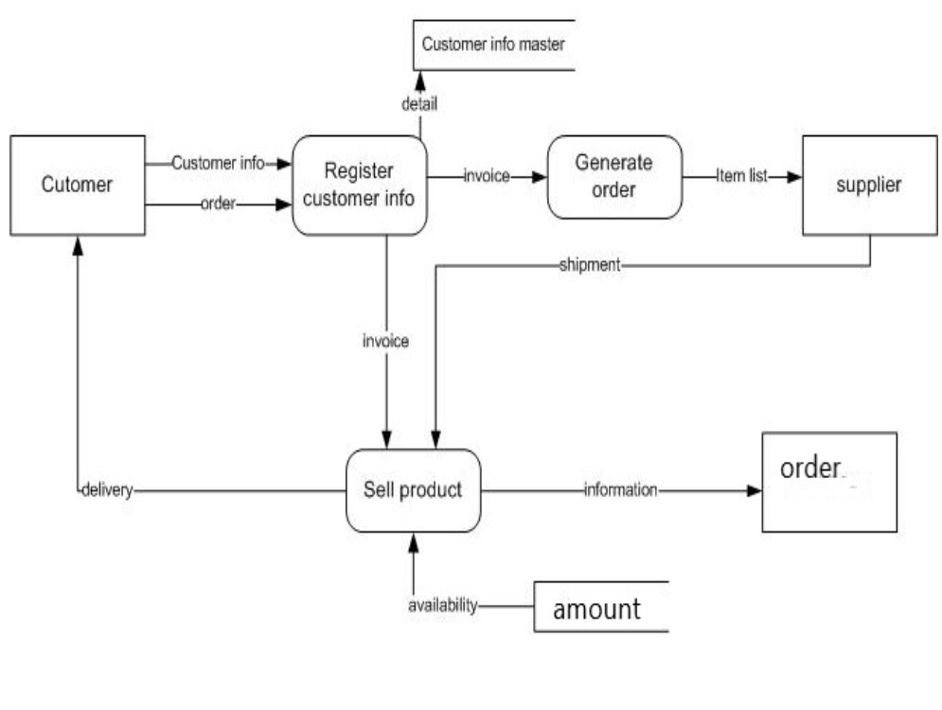

* + **Entity-relationship model** Diagram (ERD)

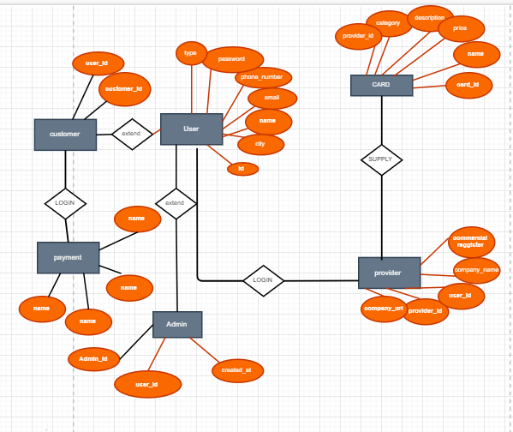

# Database Design

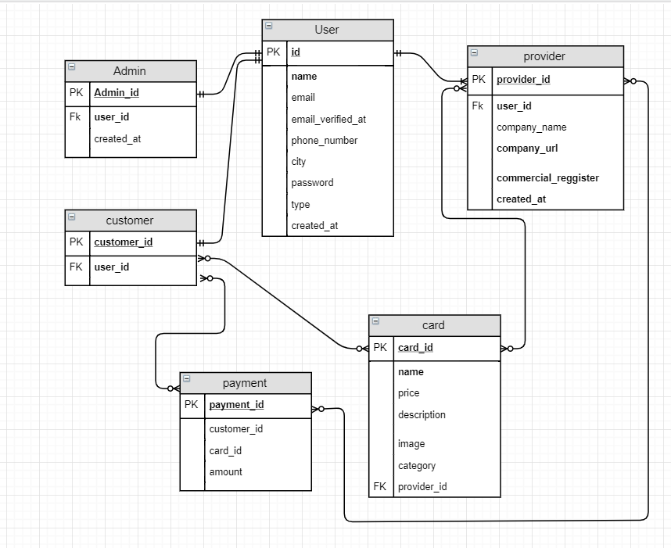

* **Database Specification**

### Providers Table

Contain the provider’s data that will open store and start selling

products.

### Users Table

Contain the register data of the providers and customers.

### cards Table

Contains all cards data that the providers will enter.

### payments Table

Contain all the data that is required for payment .

### Customers Table

Contain the data of customer that is required for register.

# Inputs and screens

### login Screen

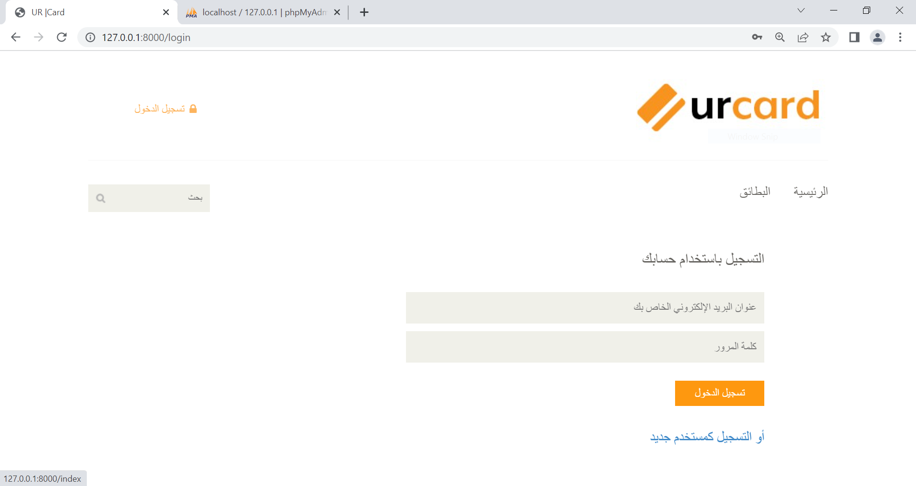

### Register Screen

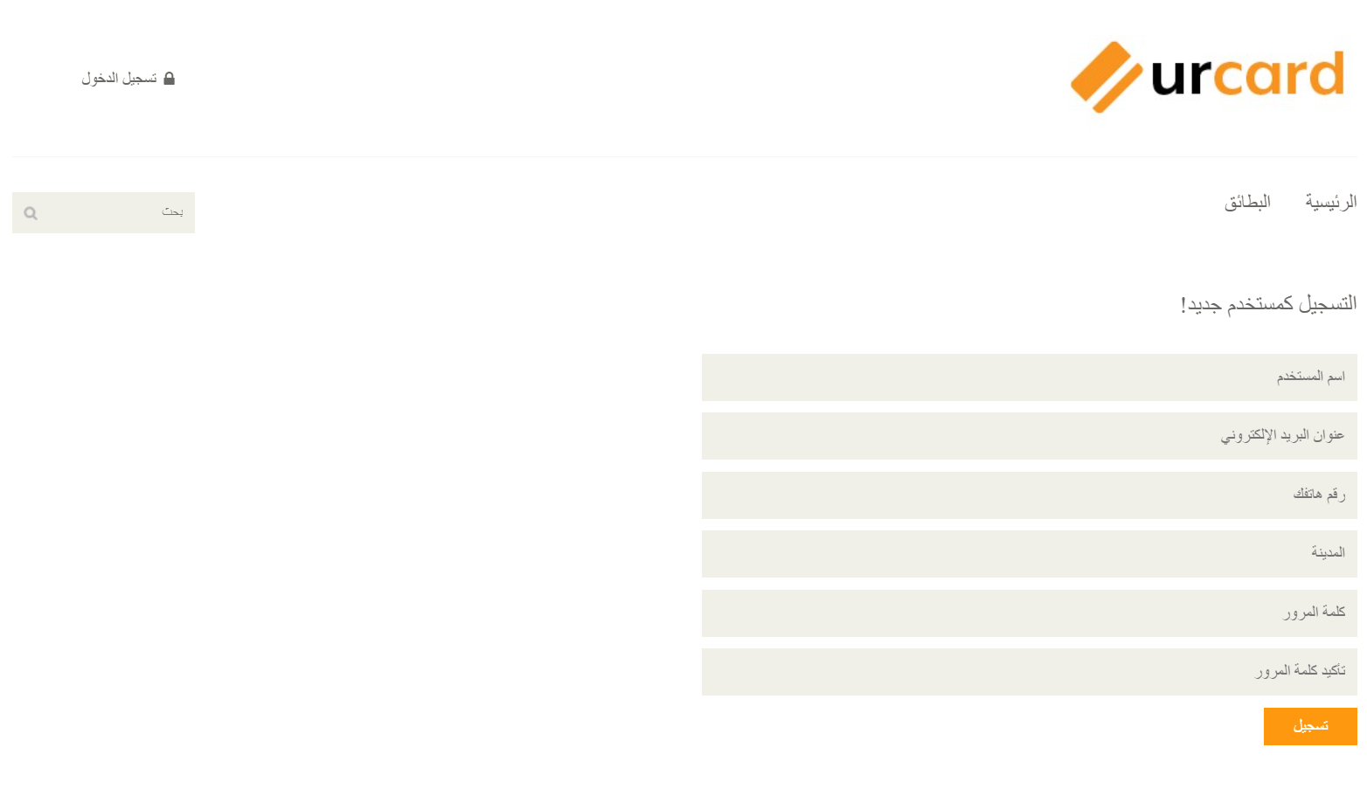

### home Screen

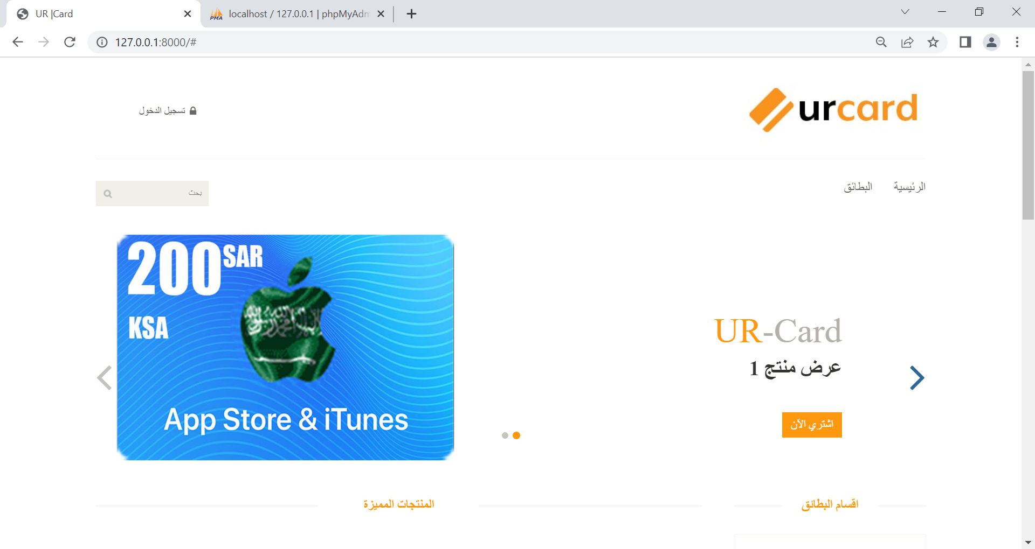

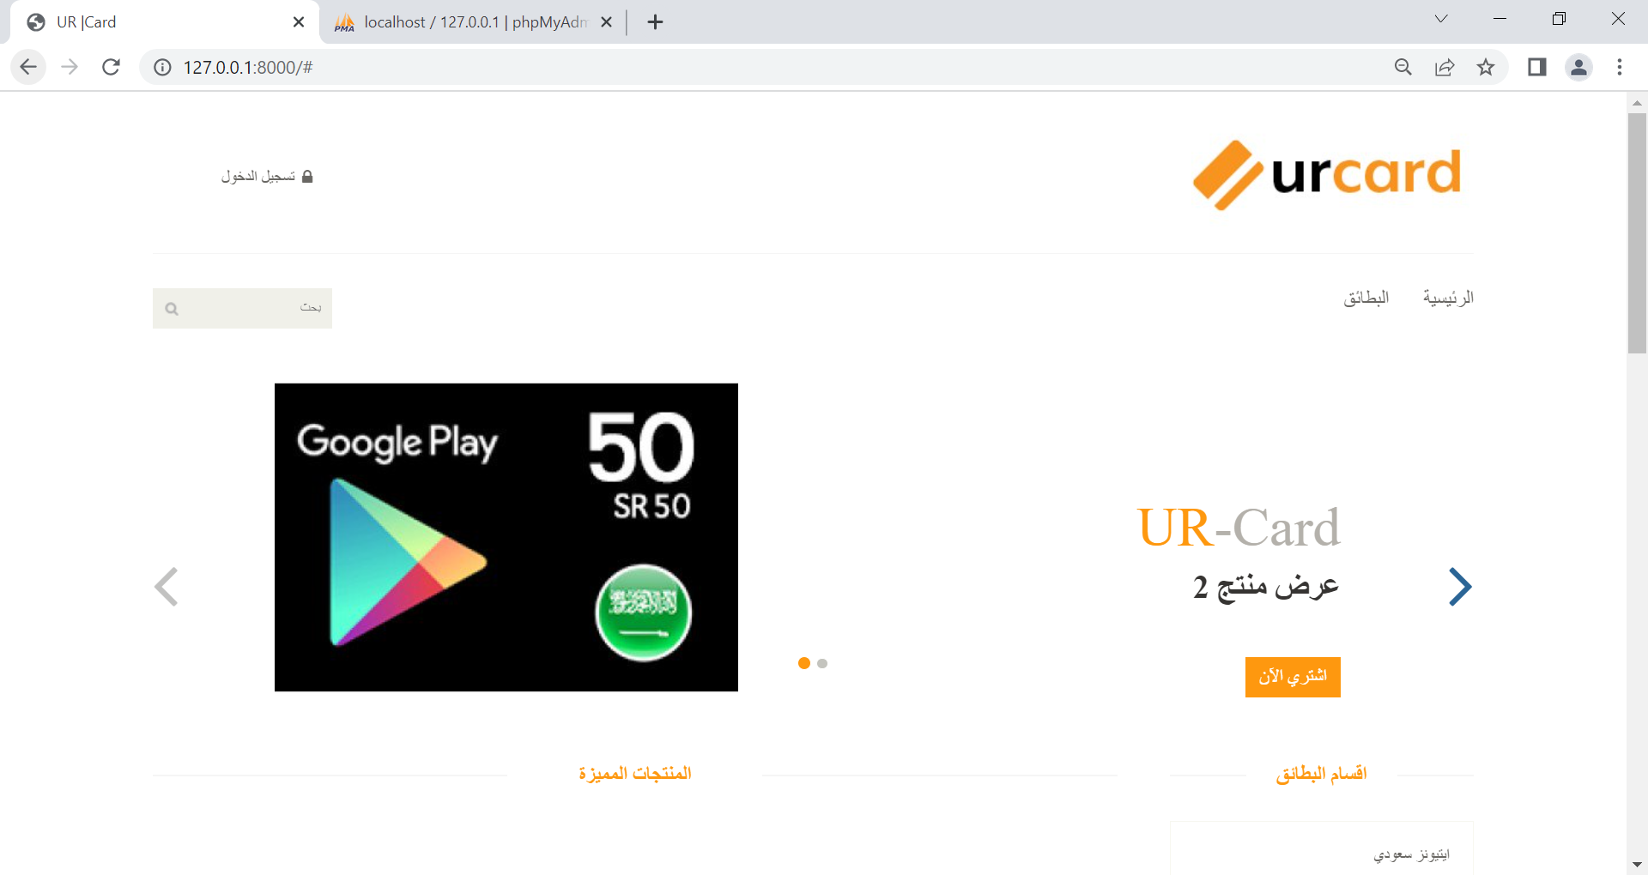

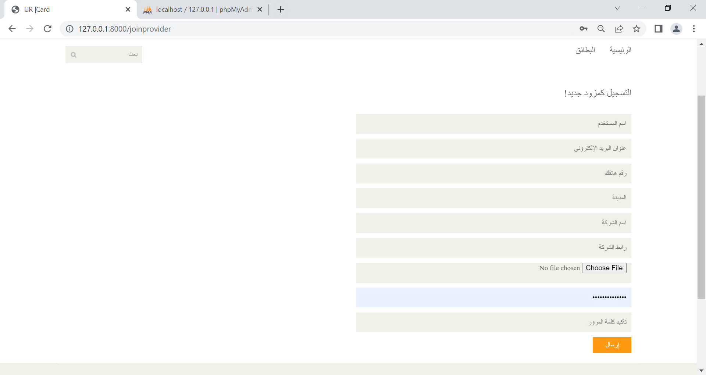

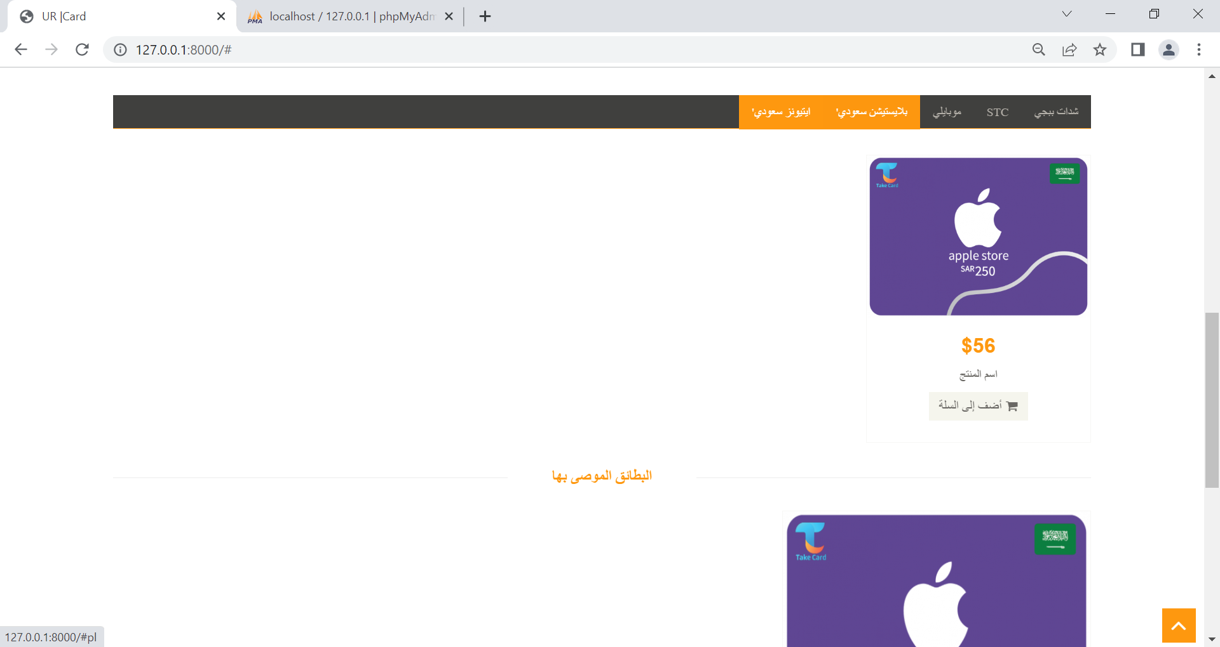

* + **add cards Screen**

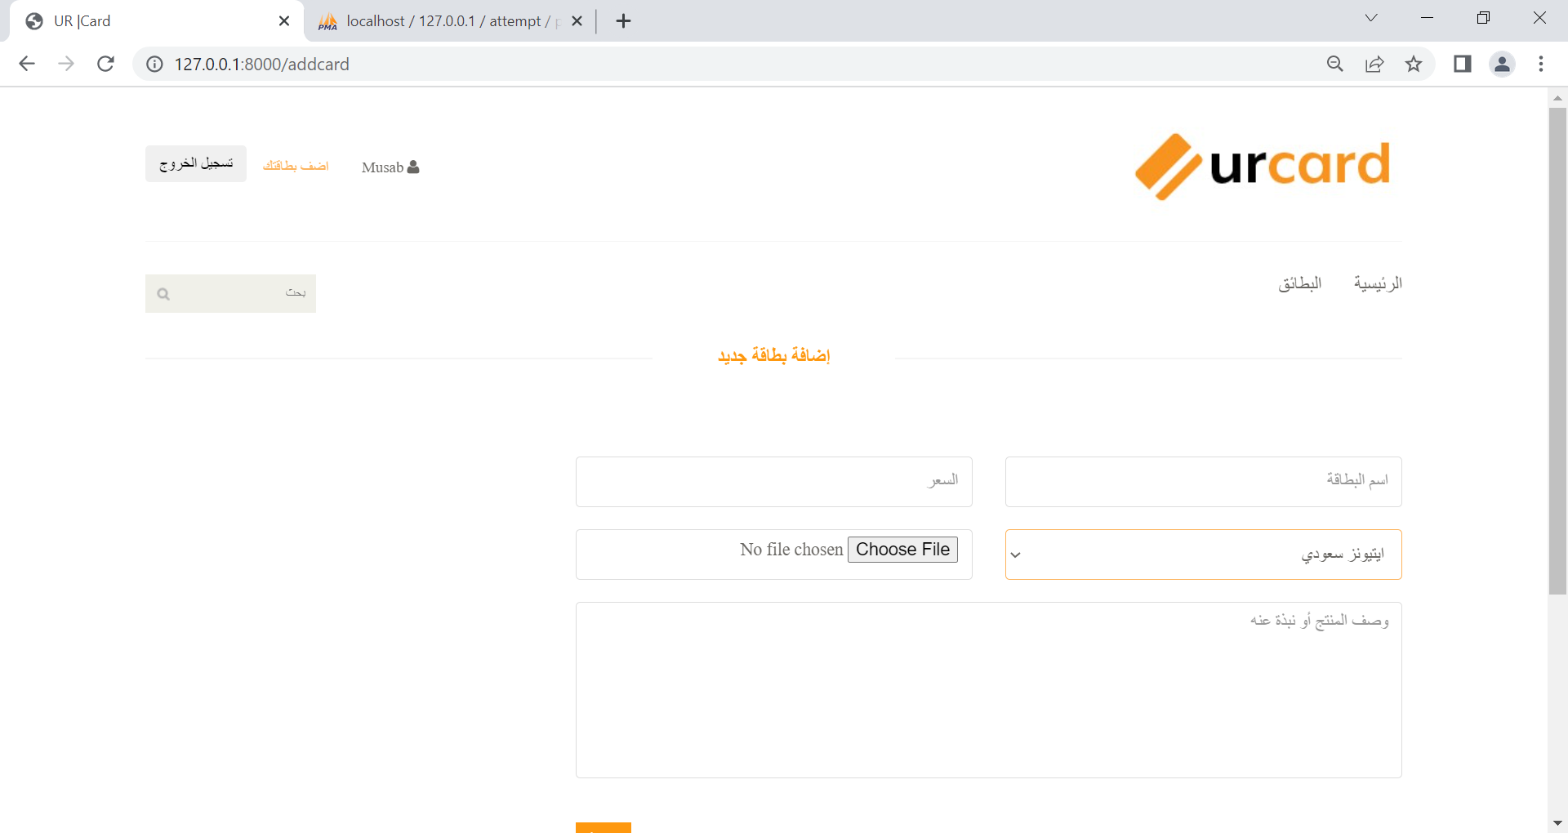

* + **Cart Screen**

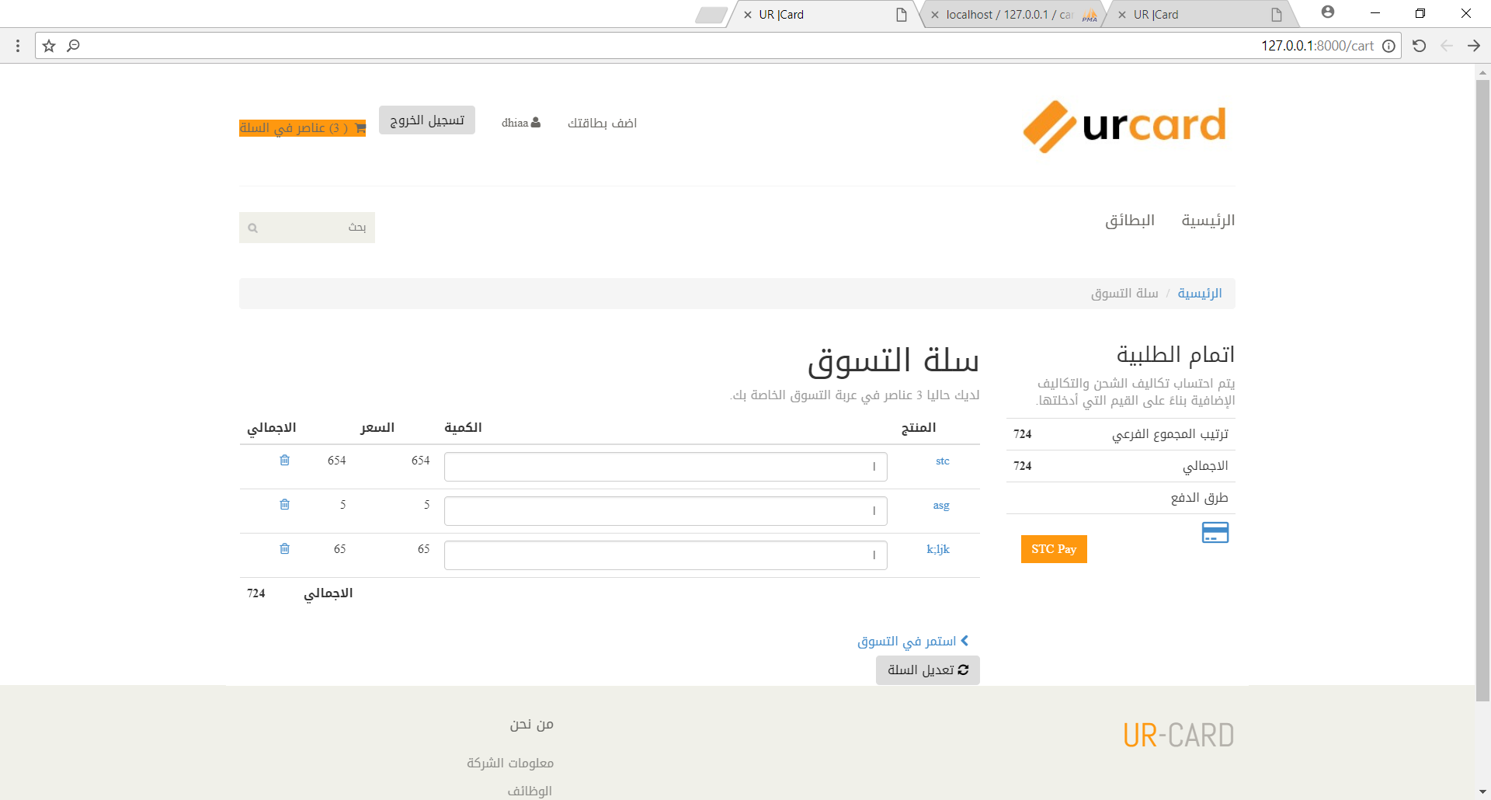

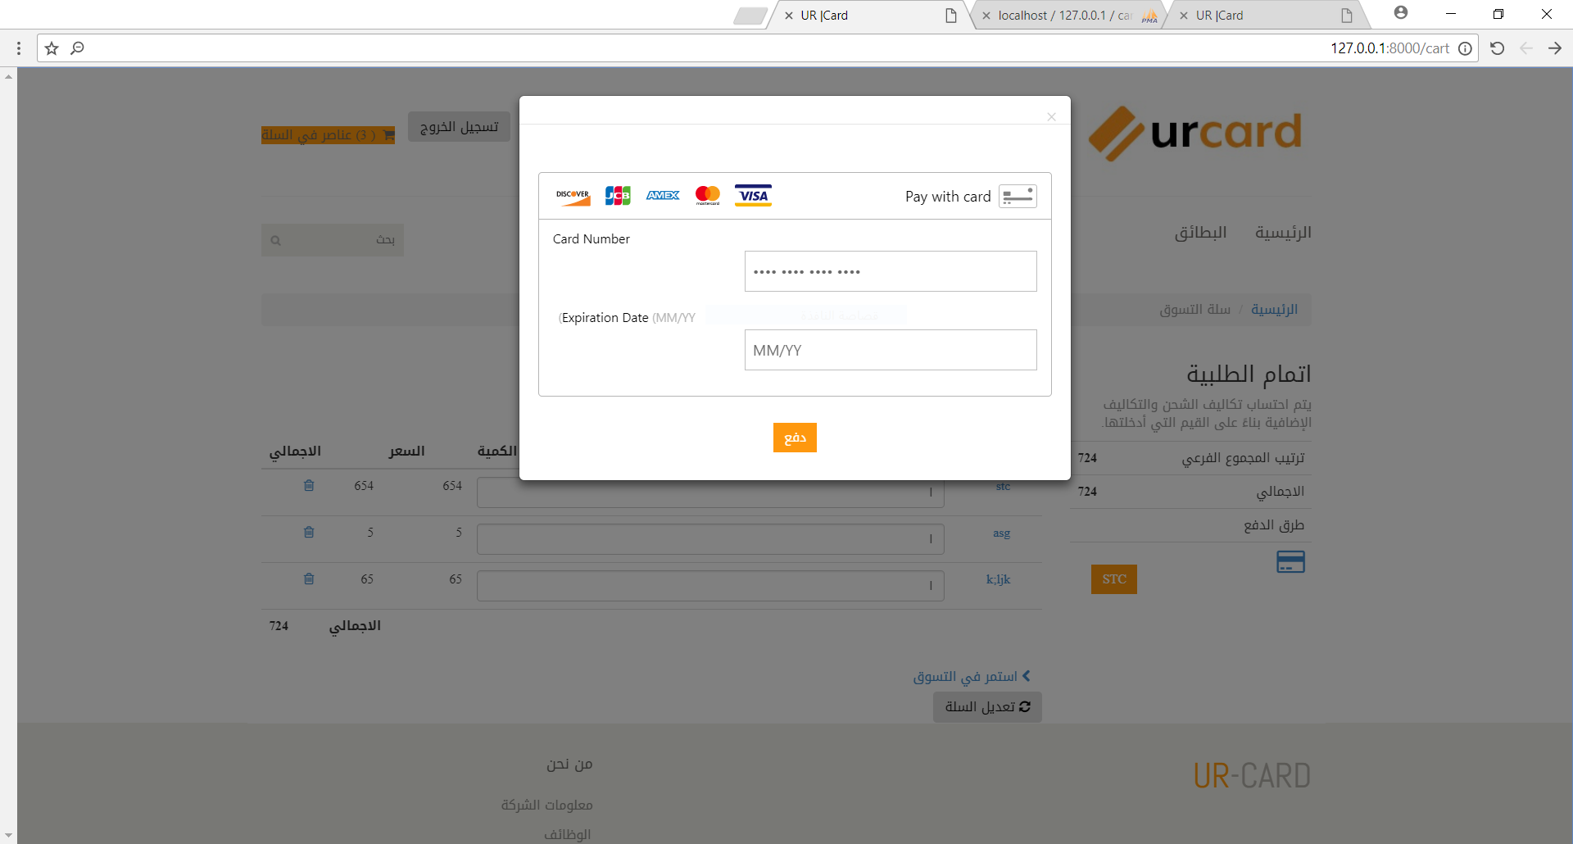

* **Payment Srcreen**

### UML Diagram

### o Class

صورة تحتوي على نص, علامة, لقطة شاشة

تم إنشاء الوصف تلقائياً

### UML Diagram

* **Use case**

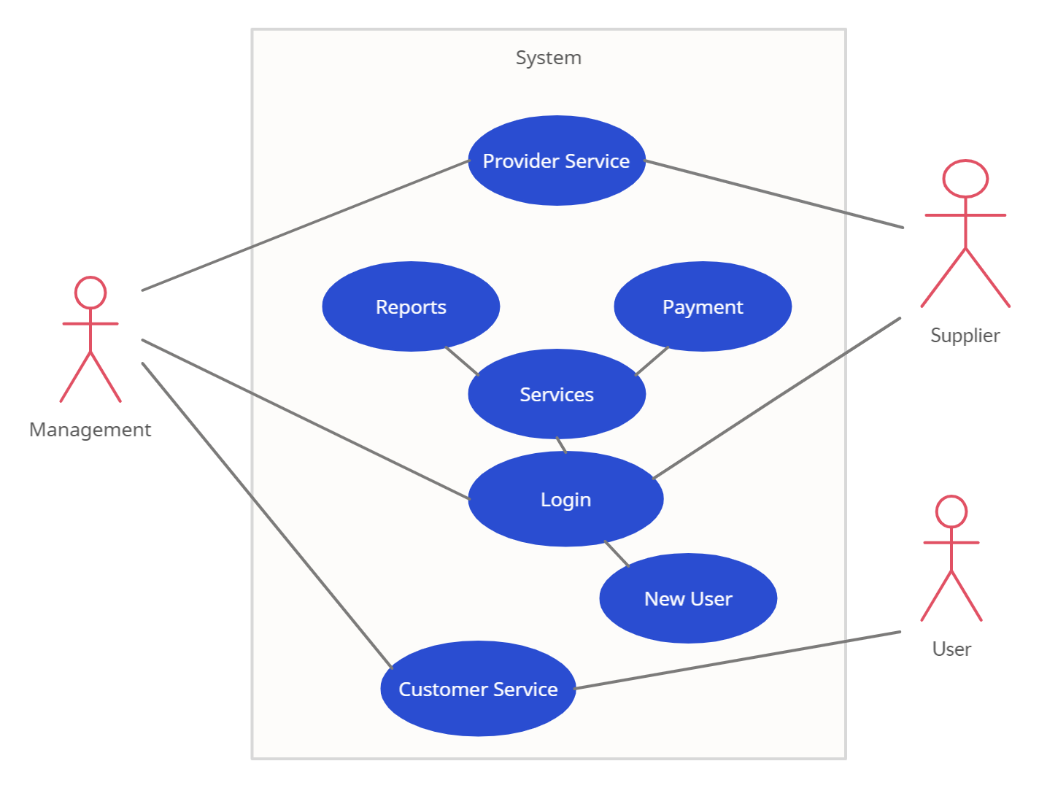

# 

### UML Diagram

* **Sequence**

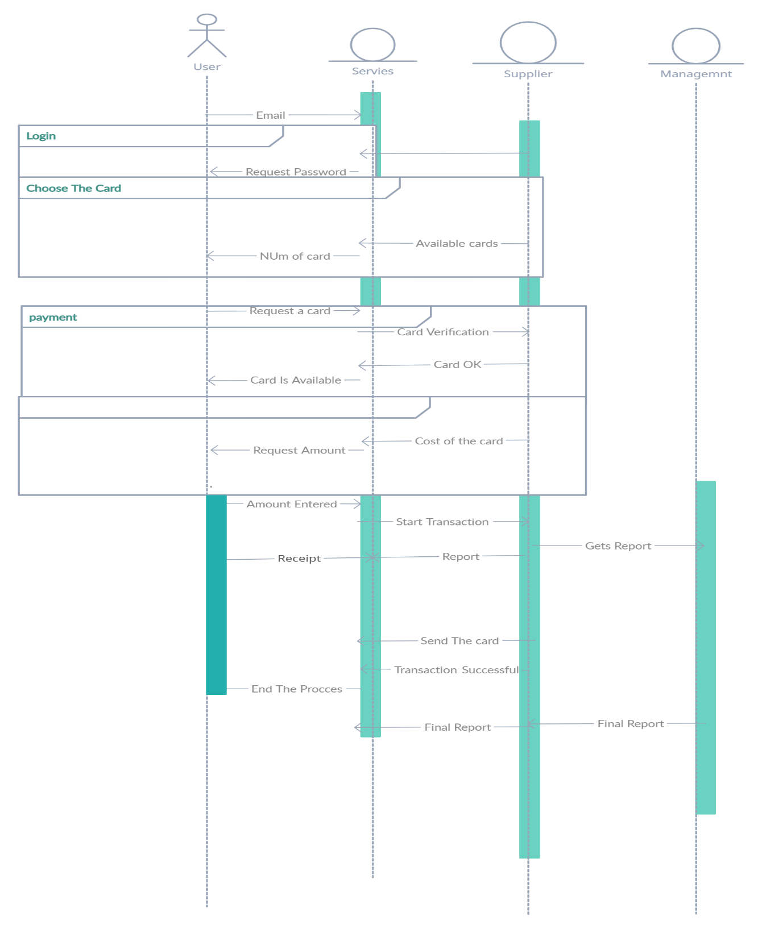

### UML Diagram

### Flowchart

Activate diagram of a Provider

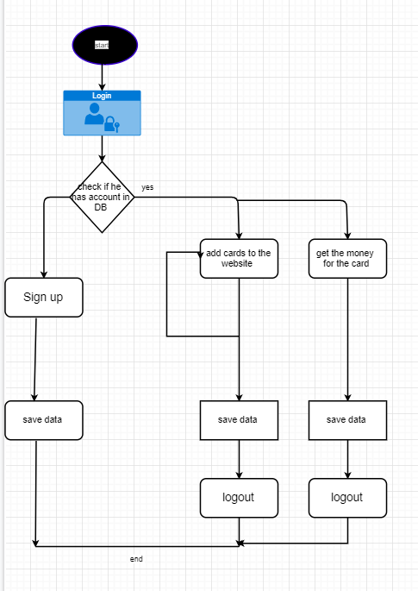

Activate diagram of a admin

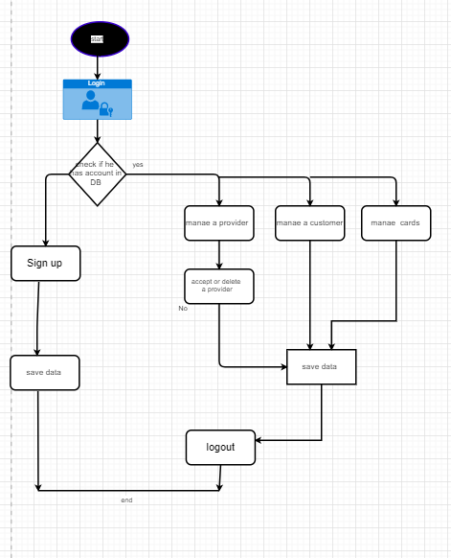

Activate diagram of a customer

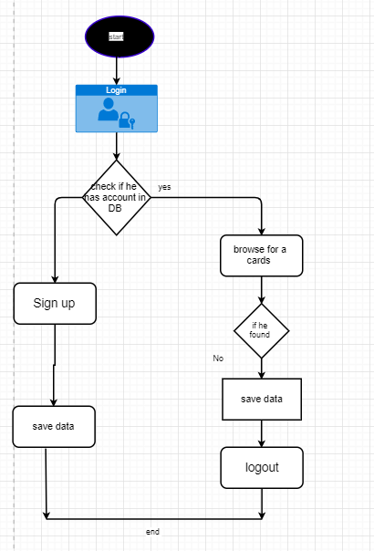

# Gantt Charts

#  

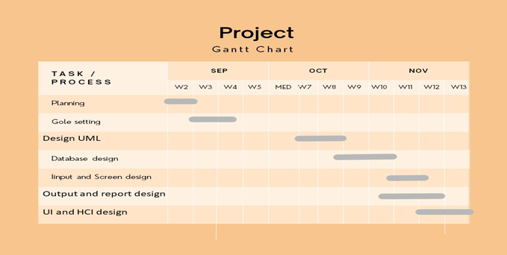

# Gantt Charts

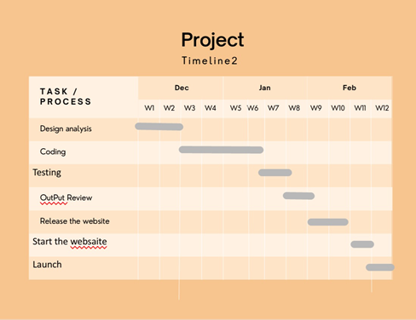

Usability study

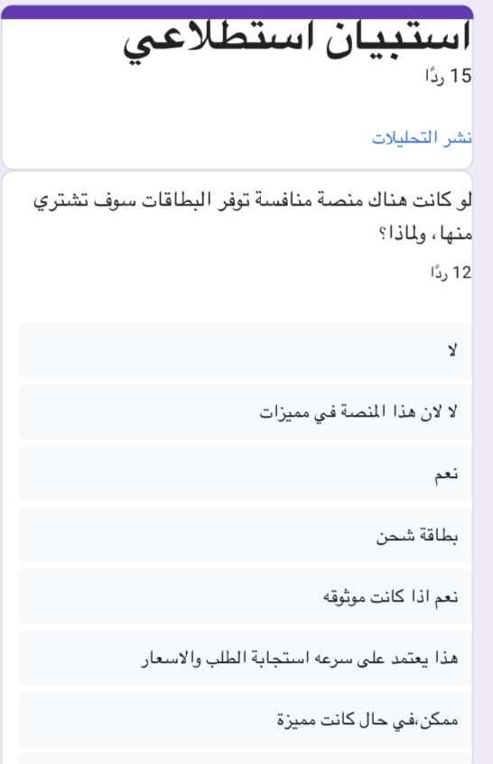

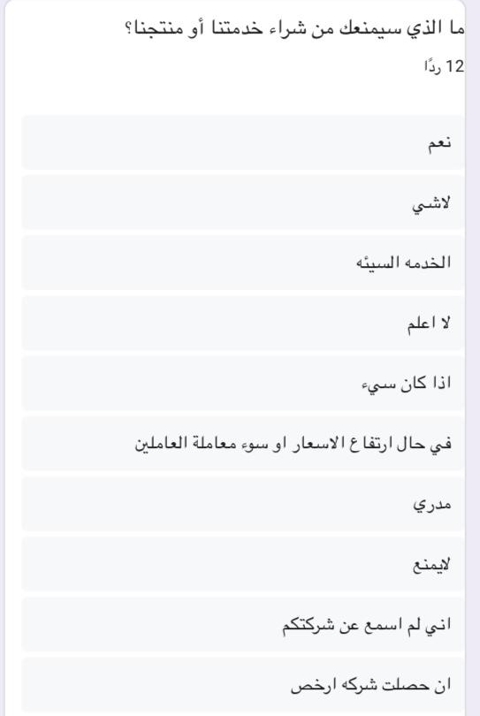

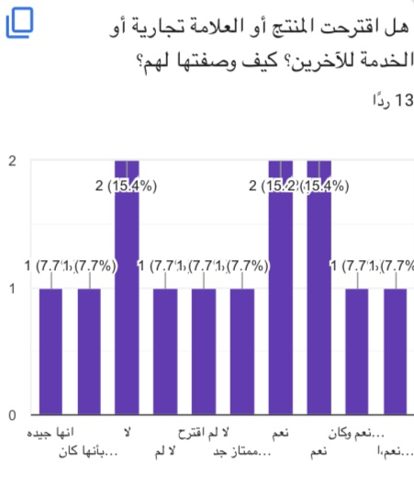

Sources and references

**‎‏1-HARAJ**

**‎‏ Haraj, Saudi forestry that contains all goods, cars, real estate and hardware.**

**‎‏https://haraj.com.sa**

**‎‏2-NOON**

**‎‏Noon is a leading local online shopping platform in the Middle East that provides users with multiple options of products, categories and brands to shop online.**

**https://www.noon.com**

Conclusion

**In conclusion, this is our platform Ur card Building a platform to allow sellers to present thier products to the customer. These products will be mainly digital cards such as playstation plus, iTunes, and more.**

**The website will be running 24/7.**

**We hope you like the ideaThank you.**